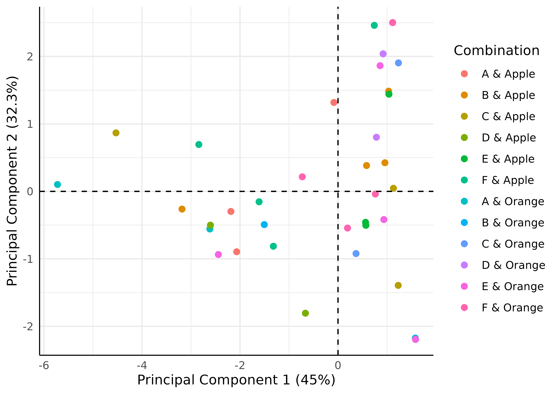

PCA Ellipse-None

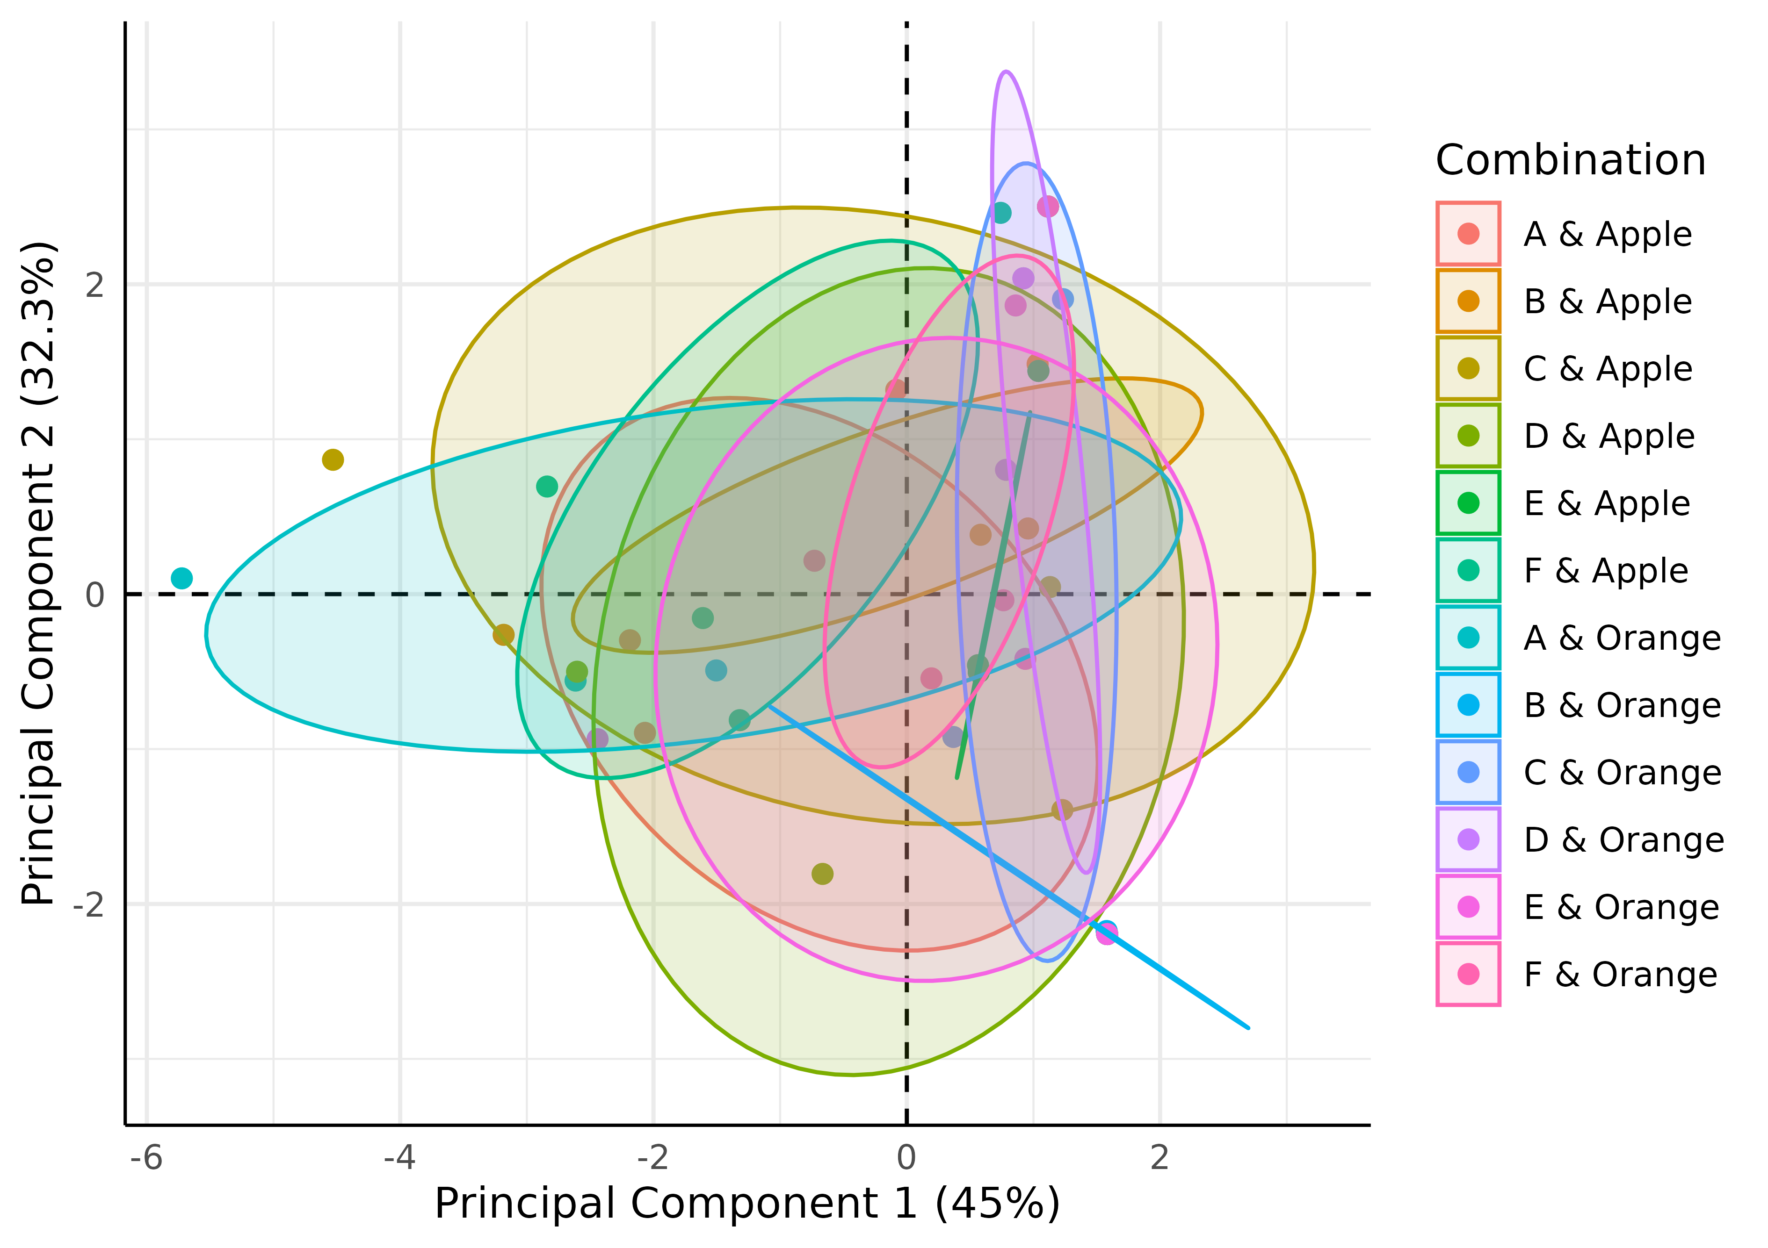

PCA Ellipse-Confidence

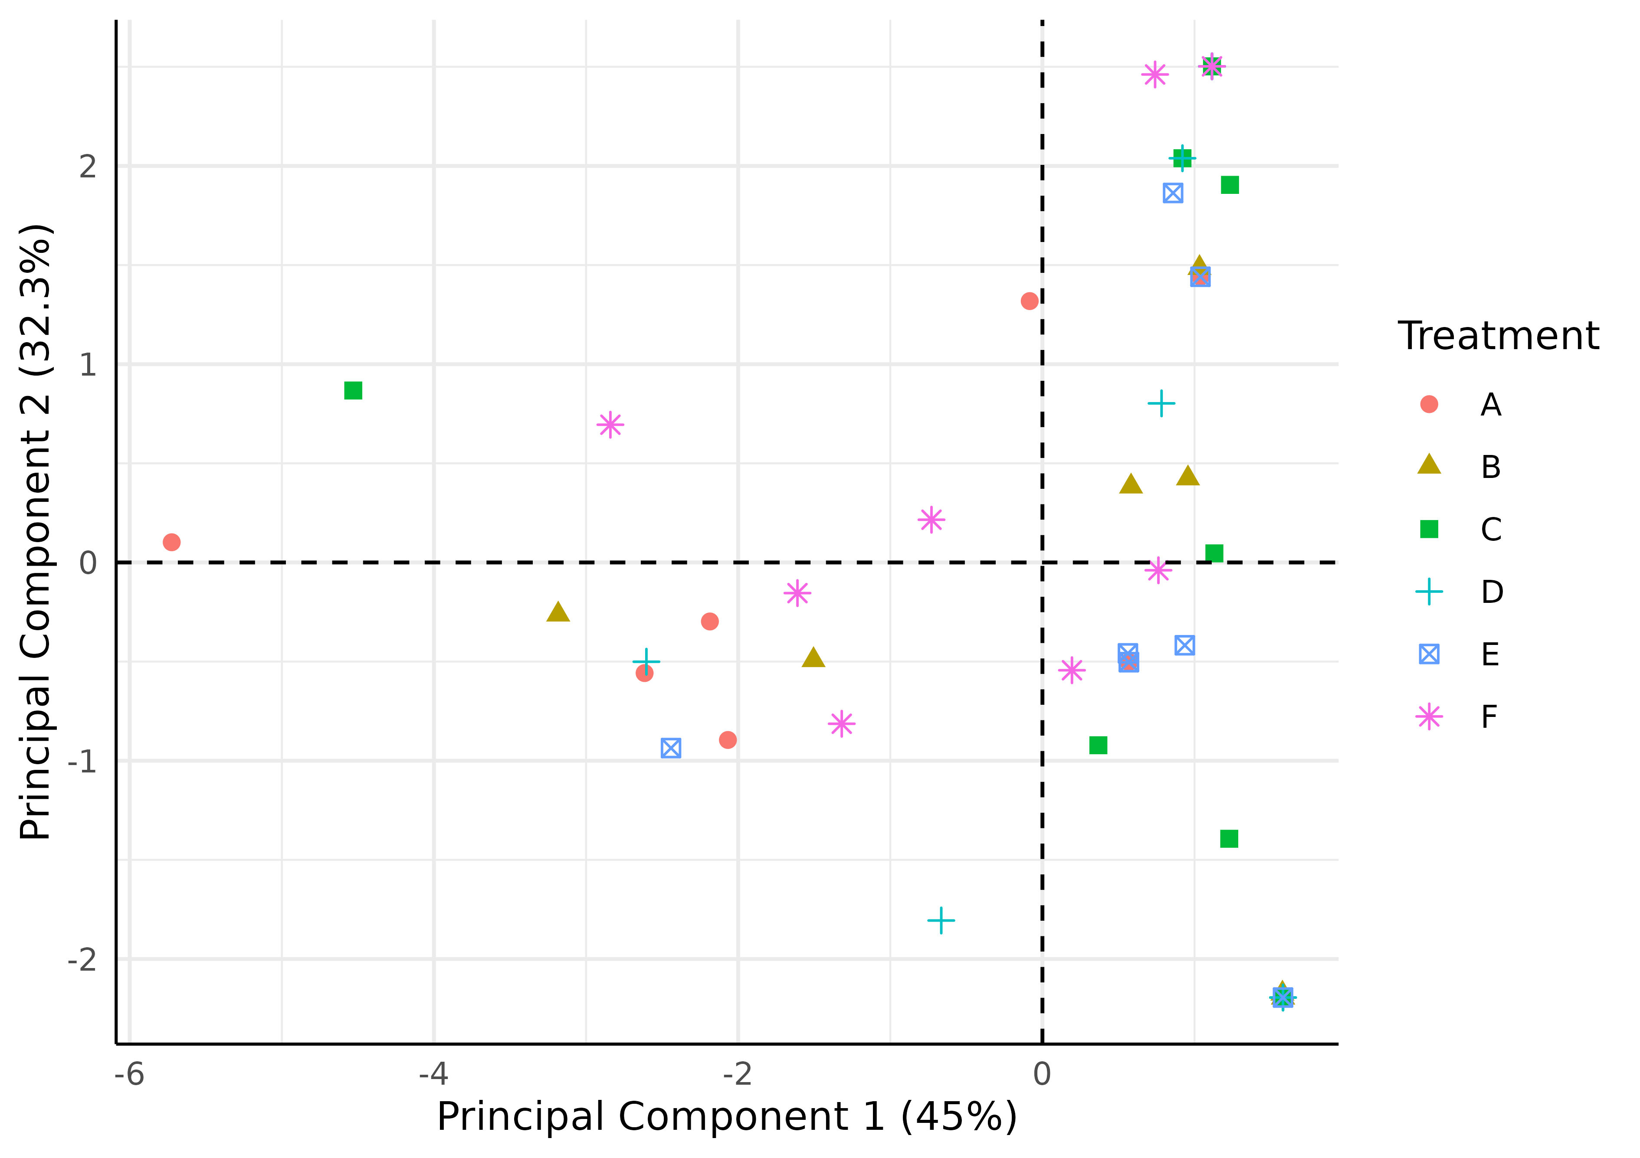

PCA Pooled Across-Fruits Ellipse-None

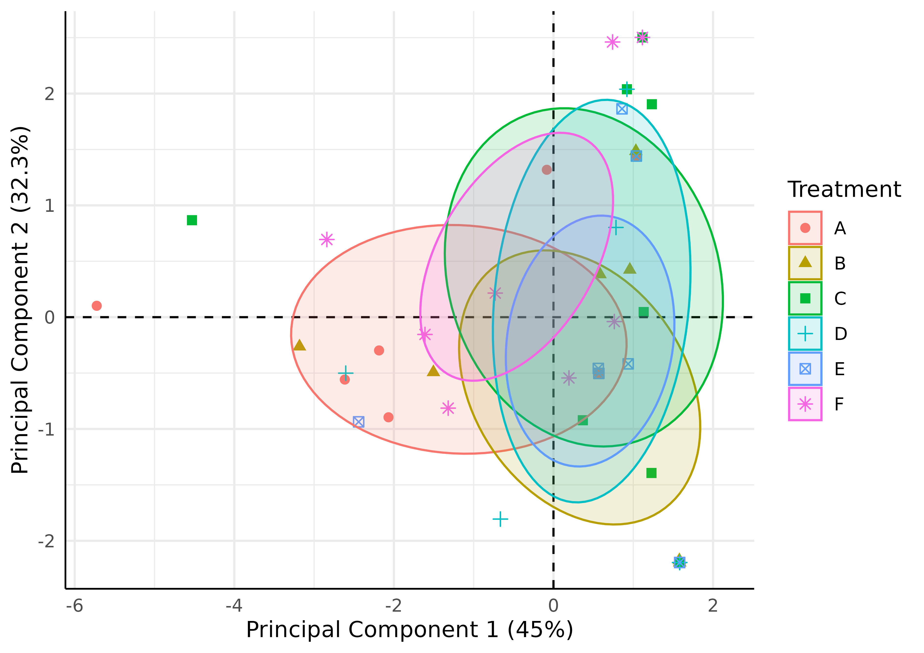

PCA Pooled Across-Fruits Ellipse-Confidence

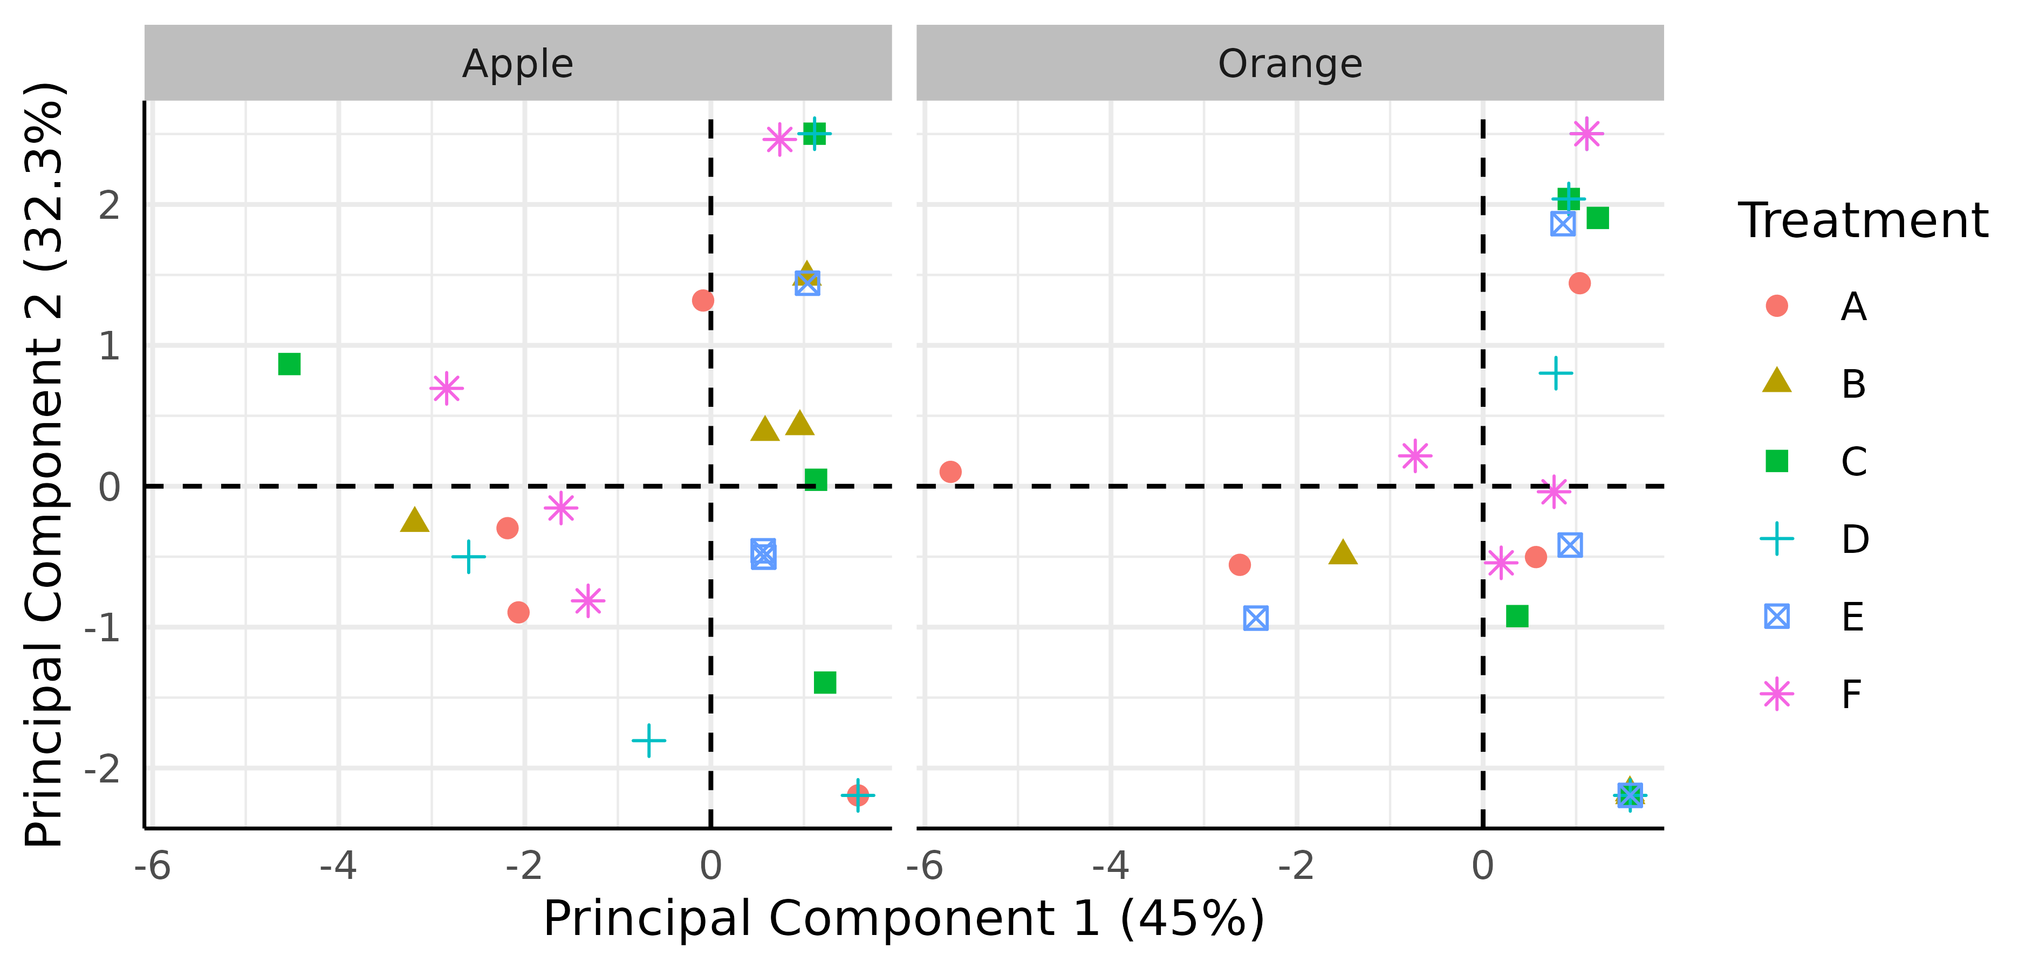

PCA Facet-Fruits Ellipse-None

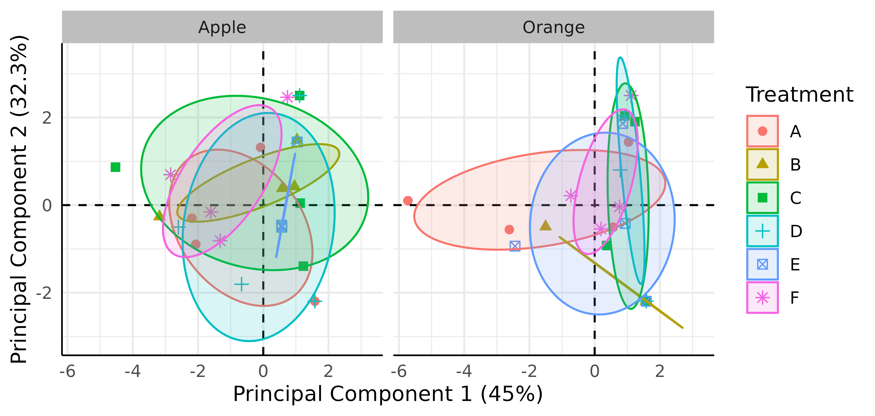

PCA Facet-Fruits Ellipse-Confidence

The 45% and 32.3% values in the axes of the figures above describe the percent variation in the data explained by the first and second principal components, respectively.

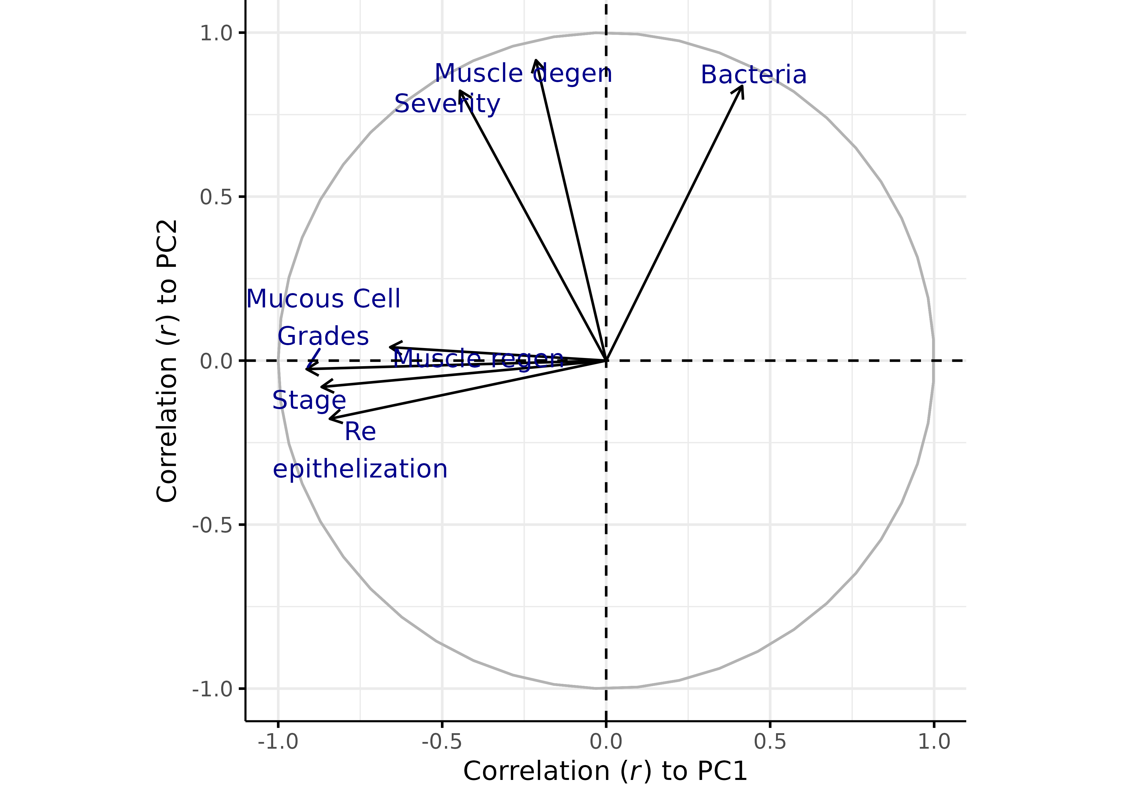

Correlation of Variables to PCs

Table 1. Pearson correlation coefficient (r) between variables and principal components

|  | Severity | Stage | Muscle degen | Muscle regen | Bacteria | Re epithelization | Mucous Cell Grades | PC1 | PC2 |
| --- | --- | --- | --- | --- | --- | --- | --- | --- | --- |
| Severity | 1.000 | 0.365 | 0.790 | 0.222 | 0.464 | 0.276 | 0.313 | -0.446 | 0.823 |
| Stage | 0.365 | 1.000 | 0.058 | 0.470 | -0.392 | 0.720 | 0.668 | -0.868 | -0.080 |
| Muscle degen | 0.790 | 0.058 | 1.000 | 0.165 | 0.606 | 0.012 | 0.208 | -0.214 | 0.916 |
| Muscle regen | 0.222 | 0.470 | 0.165 | 1.000 | -0.217 | 0.264 | 0.614 | -0.659 | 0.041 |
| Bacteria | 0.464 | -0.392 | 0.606 | -0.217 | 1.000 | -0.472 | -0.379 | 0.415 | 0.838 |
| Re epithelization | 0.276 | 0.720 | 0.012 | 0.264 | -0.472 | 1.000 | 0.756 | -0.843 | -0.177 |
| Mucous Cell Grades | 0.313 | 0.668 | 0.208 | 0.614 | -0.379 | 0.756 | 1.000 | -0.914 | -0.026 |
| PC1 | -0.446 | -0.868 | -0.214 | -0.659 | 0.415 | -0.843 | -0.914 | 1.000 | -0.000 |
| PC2 | 0.823 | -0.080 | 0.916 | 0.041 | 0.838 | -0.177 | -0.026 | -0.000 | 1.000 |

Table 2. Contribution of variables to principal components

| Variable | ContributionPC1 | EigenvectorPC1 | ContributionPC2 | EigenvectorPC2 |
| --- | --- | --- | --- | --- |
| Mucous Cell Grades | 26.511201 | -0.5148903 | 0.02947700 | -0.01716887 |
| Stage | 23.918311 | -0.4890635 | 0.28588643 | -0.05346835 |
| Re epithelization | 22.556382 | -0.4749356 | 1.39435609 | -0.11808286 |
| Muscle regen | 13.782113 | -0.3712427 | 0.07405029 | 0.02721218 |
| Severity | 6.315563 | -0.2513078 | 29.98374953 | 0.54757419 |
| Bacteria | 5.458917 | 0.2336432 | 31.07119702 | 0.55741544 |
| Muscle degen | 1.457515 | -0.1207276 | 37.16128364 | 0.60960055 |

The contribution describes how much (in %) of the PC is composed of that variable; a more precise definition is that it is the variable's eigenvector^2 when the sum of eigenvectors^2 (over all variables) is equal to 1 (100%) for each PC (this condition is implicit in PCA). The eigenvector represents both the magnitude and direction of change of the principal component for each unit increase of the variable. This variable is in the standardized scale (z-score normalized) if scale and center arguments are set to TRUE.